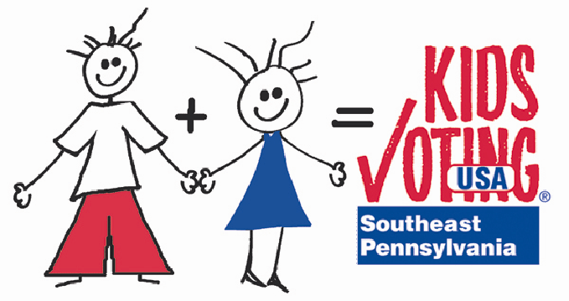
Kids Voting Building Activities
Ideas to create excitement about voting

Back to School Night
  - Have voter registration forms available for parents
  - Have sign-ups for parents to volunteer to work at the KV polls on Election Day
  - Have parents write their wish for the country and put on a wish tree
Participate in school wide election created by school - some ideas are: favorite book (primary and intermediate); favorite snack you want the cafeteria to sell; item you want the PTO to purchase, etc.)
Hold a Kids Voting Family Fun Night
  - Invite candidates (all parties) to visit school

Participate in school elections – from getting a petition to run for office, campaigning, speeches, elections
Borrow county voting machine (before September 15) and students use it to vote
Make a prediction who will win gubernatorial race (kids vote in class – this will allow the chance for all kids to vote as realistically some kids may not go to the polls)
Have a red, white and blue spirit day on or before Election Day
Have students participate in Kids Voting online surveys
Election Day scavenger hunt – hunt through newspapers and other resources for election-related news, photos, editorials and more
League of Women Voters posters – kids decorate and post in local businesses
Student council elections

